**CSE523 Machine Learning**

**Heart Attack Prediction**

|  |  |
| --- | --- |
| **Group Members** | **Roll No** |
| **Shivam Thakker** | **AU1940193** |
| **Devarsh Sheth** | **AU1940189** |
| **Pranav Gandhi** | **AU1940313** |
| **Meet Jhaveri** | **AU1940284** |

**Group-3 Weekly Report-8**

In this week, we have tried to do models.

So, firstly we have tried to apply random forest on our dataset.

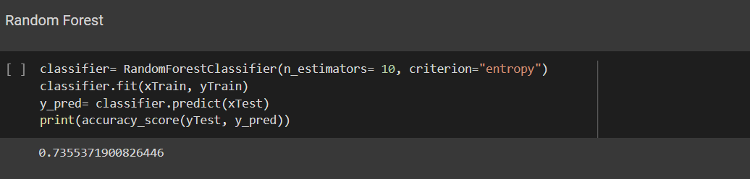

In this case, we got the accuracy of 74%.